Pacific Gas and Electric Company
Release 9.7.6 Installation Guide
Project | ED AM/GIS
Prepared by | Subhankar Baidya
Date | 10/29/2015
Version | 1.0
Version Type | Draft

Revision History
Document # | Date | Author | Summary of Changes
1.0 | 10/01/2015 | Subhankar Baidya | Initial Document Creation
1.1 | 10/21/2015 | Roger Carribine | Added 9.7.6B

Introduction

Purpose
This document is intended to detail the implementation and configuration steps required to implement Release 9.7.6 Installation Guide. This document describes the various configuration aspects required to complete any manual or automatic patch associated with this release. Each section in this document contains the steps required to patch the system in production.

Terms Used
OOTB | Out of the box. Unmodified from the commercial version.
TFS | Team Foundation Server

External Documents
Referenced are any external configuration documents or exports. These are documents that contain more detailed information about configuring a system or documents that can be loaded into an application to perform the configuration detailed in this document.
- Supporting documentation folder
  - TFS documentation location:
$/EDAMGIS/Source_Development_10_2_1/Documentation/Data Model/Release Documentation/EDER/9.7.6

http://edappgistfsprd1:8080/tfs/ElectricDistCollection/EDAMGIS/_versionControl#path=%24%2FEDAMGIS%2FSource_Development_10_2_1%2FDocumentation%2FData+Model%2FRelease+Documentation%2FEDER%2F9.7.6&_a=contents

List of Fixes
Below is the list of change requests detailing all fixes for the data model for this release:

Item Number | Title
24736 | Master TFS DM 9.7.6
24646 | Modify Transformer.SpotIDC Attribute to Match SAP and IVARA
24647 | Add New Domain "Insulating Fluid Type"
24673 | Add Attribute InsulatingFluidType to Switch and OpenPoint Features (for IVARA)
24674 | Assign Insulating Fluid Type Domain to InsulatingFluidType Attribute on 4 Features
24692 | Add SupervisoryControl Attribute to TransformerDevice (Primary Connection Chamber)
24696 | Add New Domain Bottom or Top
24698 | Add New Attribute to LinkLocation to NetworkProtector
24700 | Add New Attribute SupervisoryControl to NetworkProtector
24701 | Add New Attribute SupervisoryControl to OpenPoint
24702 | Add New Domain Enclosure Type
24703 | Add New Attribute EnclosureType to NetworkProtector
24800 | Turn on Neutral Conductor 50 scale Annotation by default
24804 | Assign ArcFM Create Feeder Object to Dist BusBar and make Sec Dist Bus Bar tracable
24797 | Snapping Rules for Downtown Network Features
24810 | Update to EDER Field Properties for Network Features
24170 | PARS 114655 Missing code/value from "Trans Unit Type Sub Surface" domain
24890 | Create FDI tables and view in EDER
24864 | Make MHCOVERSIZE field (Manhole Cover Size) of Subsurface Structure feature class visible
25125 | Resolve IVARA Device Manufacturer Domain and ED0006 domains.xml Defect
25185 | Make SAPSORTFIELD field of Ground Switch visible
25186 | Make City and Zip fields of TransformerDevice (Primary Connection Chamber) visible
22399 | DA Issue: Add Schematic Values to ErrorType Domain
25273 | Remove "Validate Source Connectivity" QC rule from DC Rectifier
25274 | Prevent 50 scale linear features from resetting annotation when shape updated
25349 | Assign "Not Applicable - String" domain to SpotIDC field for non-network Transformer subtypes
25413 | Modify Transformer symbol number config

Contents
1 Introduction 3
1.1 Purpose 3
1.2 Terms Used 3
1.3 External Documents 3
1.4 List of Fixes 4
2 EDGIS 9.7.6 6
2.1 Apply 9.7.6 Python Script 6
2.2 24646: Modify Transformer.SpotIDC Attribute to Match SAP and IVARA 6
2.3 24673:Add Attribute InsulatingFluidType to Switch and OpenPoint Features (for IVARA) 7
2.4 24701: Add New Attribute SupervisoryControl to OpenPoint 11
2.5 24800: Turn on Neutral Conductor 50 scale Annotation by default 13
2.6 24804: Assign ArcFM Create Feeder Object to Dist Busbar and make Sec Dist Bus Bar tracable 14
2.7 24797: Snapping Rules for Downtown Network Features 16
2.8 24810: Update to EDER Field Properties for Network Features 19
2.9 24890: Create FDI table and views 26
2.10 24864: Make MHCOVERSIZE field (Manhole Cover Size) of Subsurface Structure feature class visible 27
2.11 25125: Resolve IVARA Device Manufacturer Domain and ED0006 domains.xml Defect 28
2.12 25185: Make SAPSORTFIELD field of Ground Switch visible 33
2.13 25186: Make City and Zip fields of TransformerDevice (Primary Connection Chamber) visible 35
3 EDGIS 9.7.6B 38
3.1 25273: Remove "Validate Source Connectivity" QC rule from DC Features 38
3.2 25274: Prevent 50 scale linear features from resetting annotation when shape updated 39
3.3 25413: Modify Transformer symbol number config 40
4 Update Data Model Version Table 42
5 Known Issues 43

EDGIS 9.7.6

Apply 9.7.6 Python Script
- Copy the 9_7_6 DataModel_Updates.py file locally from the supporting documents folder referenced in Section 1.3.
- Right click on the .py file and open it in IDLE editor.
- Edit the “Data_Connection” in the file to use the correct SDE file. This SDE file should connect to the database as EDGIS.
- Release all existing locks in the SDE to ensure exclusive connection. Execute the script.
- Ensure there is no error occurred. Copy the logs into a text file and attach to the TFS ticket.

*** Apply rest of the change requests only after the python script ran successfully.

24646: Modify Transformer.SpotIDC Attribute to Match SAP and IVARA
- Open SQL Plus or SQL Developer with EDGIS user.
- Run below script as given below. Ensure that there is no execution error.

set serveroutput on;
declare
v_A_Table varchar2(20);
begin
dbms_output.put_line('Updating EDGIS.TRANSFORMER SPOTIDC field values...');
update EDGIS.TRANSFORMER set SPOTIDC='S' where SPOTIDC='Y';
update EDGIS.TRANSFORMER set SPOTIDC='G' where SPOTIDC='N';
update EDGIS.TRANSFORMER set SPOTIDC='NA' where SUBTYPECD in (1, 2, 3, 4, 7, 8);
select 'A'||(select REGISTRATION_ID from sde.table_registry where TABLE_NAME='TRANSFORMER') into v_A_Table from DUAL;
dbms_output.put_line('Transformer ''A'' table: ' || v_A_Table);

dbms_output.put_line('Updating EDGIS.' || v_A_Table || ' SPOTIDC field values...');
execute immediate 'update EDGIS.' || v_A_Table || ' set SPOTIDC=''S'' where SPOTIDC=''Y''';
execute immediate 'update EDGIS.' || v_A_Table || ' set SPOTIDC=''G'' where SPOTIDC=''N''';
execute immediate 'update EDGIS.' || v_A_Table || ' set SPOTIDC=''NA'' where SUBTYPECD in (1, 2, 3, 4, 7, 8)';
commit;
dbms_output.put_line('Done!!!');
end;

24673:Add Attribute InsulatingFluidType to Switch and OpenPoint Features (for IVARA)

- Connect to database with EDGIS user.
- Navigate to ElectricDataSet EDGIS.SWITCH. Right click on it. Select “ArcFM Properties Manager”.
- Go to “Field Info” tab. Select “All” from subtype dropdown.
- Select INSULATINGFLUIDTYPE field.
- Set Visible= “No”; Editable= “No”; Allow NULL Values = “Yes”.

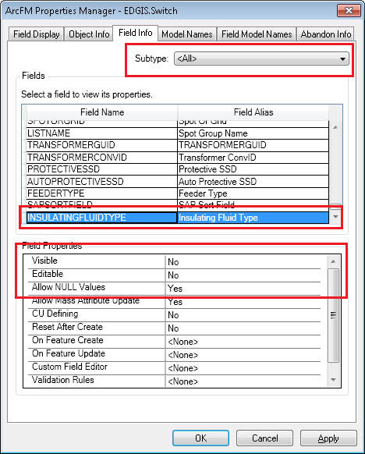

- Click “Apply” button.
- Select “Ground Switch” subtype.
- Select INSULATINGFLUIDTYPE field. Set Visible= “Yes”; Editable= “Yes”; Allow NULL Values = “Yes”.

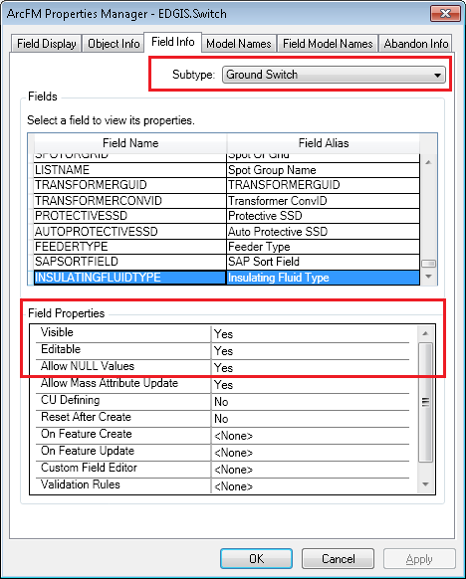

- Click “Apply. Click OK.
- Navigate to ElectricDataSet EDGIS.OPENPOINT. Right click on it. Select “ArcFM Properties Manager”.
- Go to “Field Info” tab. Select “All” from subtype dropdown.
- Select INSULATINGFLUIDTYPE field.
- Set Visible= “No”; Editable= “No”; Allow NULL Values = “Yes”.

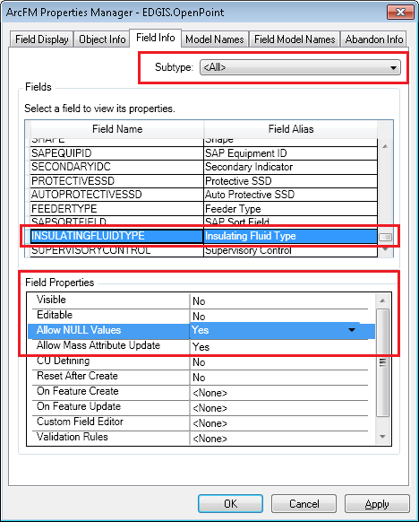

- Click “Apply” button.
- Select “Dead Break Elbow” subtype.
Select INSULATINGFLUIDTYPE field. Set Visible= “Yes”; Editable= “Yes”; Allow NULL Values = “Yes”.

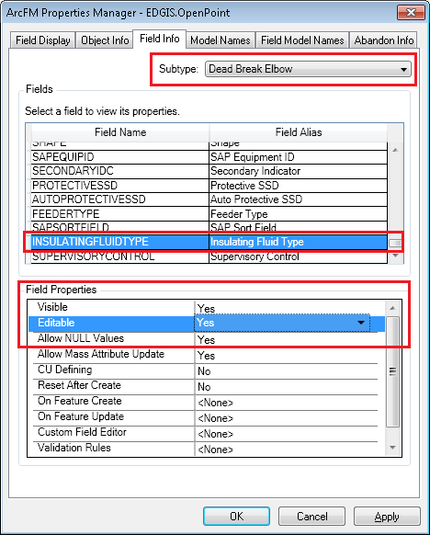

- Click “Apply. Click OK.

24701: Add New Attribute SupervisoryControl to OpenPoint
- Connect to database with EDGIS user.
- Navigate to ElectricDataSet EDGIS.OPENPOINT. Right click on it. Select “ArcFM Properties Manager”.
- Go to “Field Info” tab. Select “All” from subtype dropdown.
- Select SUPERVISORYCONTROL field.
- Set Visible= “No”; Editable= “No”; Allow NULL Values = “Yes”.

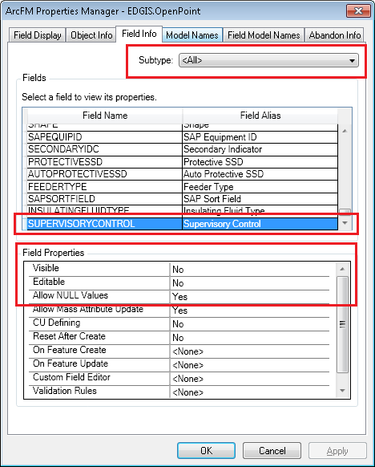

- Click “Apply.

- Select “Dead Break Elbow” subtype.
- Select SUPERVISORYCONTROL field. Set Visible= “Yes”; Editable= “Yes”; Allow NULL Values = “Yes”.

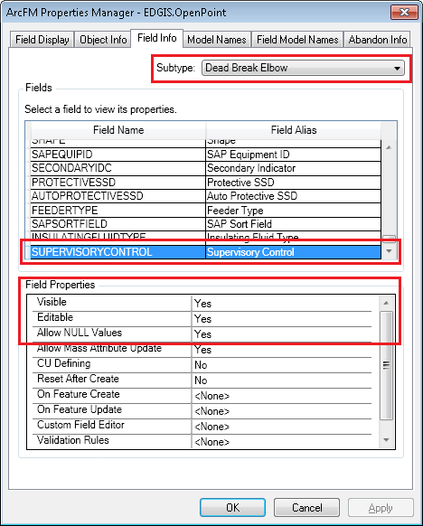

- Click “Apply. Click OK.

24800: Turn on Neutral Conductor 50 scale Annotation by default
Modify EDGIS.NeutralConductor50Anno to create its annotation by default.

- Connect to database with EDGIS user.
- Navigate to ElectricDataSet EDGIS.NeutralConductor50Anno. Right click on NeutralConductor50Anno and select Properties
- Select the Annotation tab
- Check Create annotation when new features are added
- Check Update annotation when features shape is modified
- Click OK

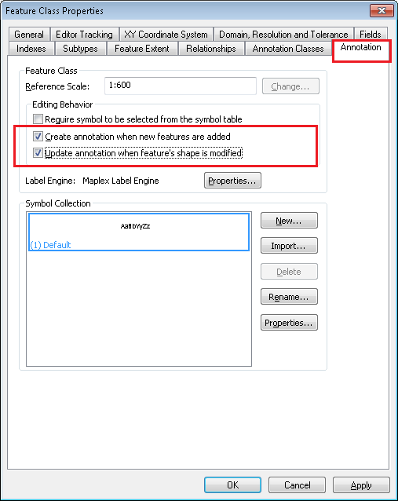

24804: Assign ArcFM Create Feeder Object to Dist Busbar and make Sec Dist Bus Bar tracable

- Connect to database with EDGIS user.
- Navigate to ElectricDataSetEDGIS.DistBusBar. Right click on it and select Properties.
- Select the Subtypes tab
- Select "Sec Dist Bus Bar" subtype in the Subtypes grid.
- In Default Values and Domains grid, navigate to TRACABLE field and set default value as 0 (zero).

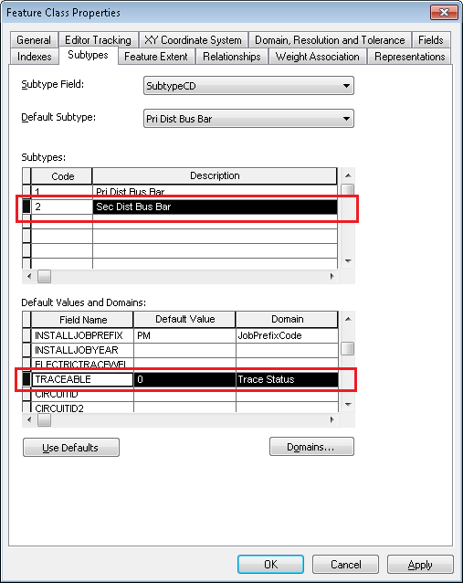

- Click Apply. Click OK.

- Right click on the DistBusBar again. Select ArcFM Properties Manager.
- Select "Object Info" tab. At "On Feature Create", click on "<Multiple>" option.
- Assign "ArcFM Create Feeder Object" AU. Place it in the 2nd position from top.

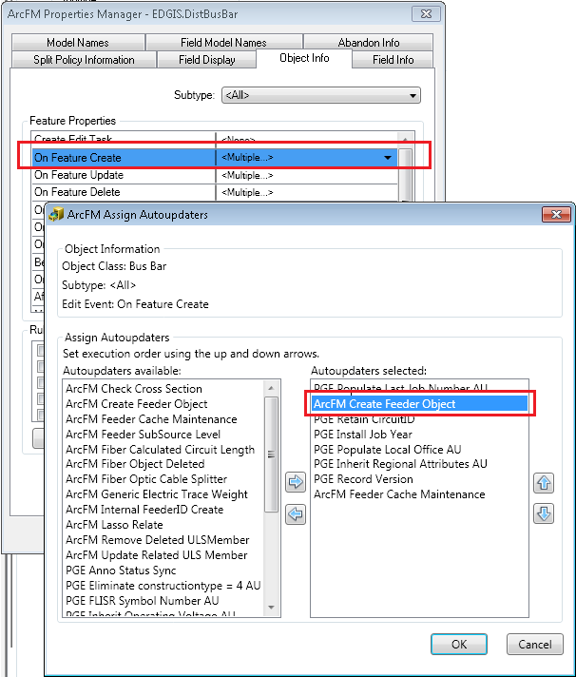

- Click OK. Click OK.

24797: Snapping Rules for Downtown Network Features

- Open ArcCatalog. Connect to database with EDGIS user.

- Navigate to ElectricDataset--> EDGIS.Transformer. Right click on it. Select "ArcFM Snapping Manager".

- In the "Subtype" list box, select "Network"

- Make sure that

  - DistributionBusBar

  - PriUGConductor

  - SecUGConductor

are available in the Snapping Target List in the same order as above.

- Check "End" checkboxes and uncheck other checkboxes for the given feature classes.

- Click Apply. Click OK.
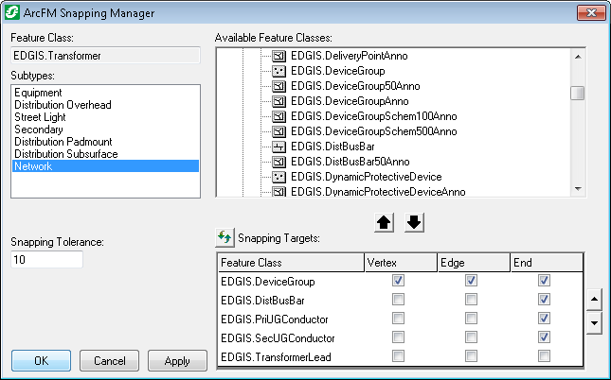

- Navigate to ElectricDataset--> EDGIS.Switch. Right click on it. Select "ArcFM Snapping Manager".

- In the "Subtype" list box, select "Ground Switch"

- Make sure that

  - DistributionBusBar,

  - PriUGConductor

  - SecUGConductor

are available in the Snapping Target List in the same order as above.
If not, Drag and drop them from the "Available Feature Classes" list to "Snapping Target List" in the same order.

- Check "End" checkboxes and uncheck other checkboxes for the given feature classes.

- Click Apply. Click OK.
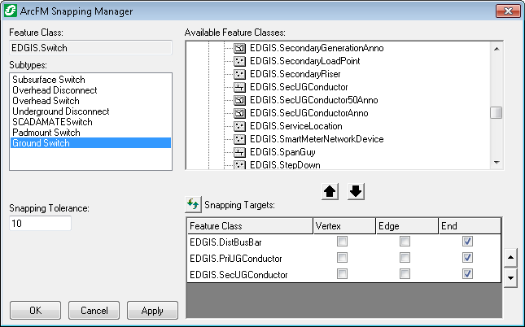

- Navigate to ElectricDataset--> EDGIS.NetworkProtector. Right click on it. Select "ArcFM Snapping Manager".

- Make sure that

  - DistributionBusBar,

  - PriUGConductor

  - SecUGConductor
are available in the Snapping Target List in the same order as above.
If not, Drag and drop them from the "Available Feature Classes" list to "Snapping Target List" in the same order.

- Check "End" checkboxes and uncheck other checkboxes for the given feature classes.

- Click Apply. Click OK.
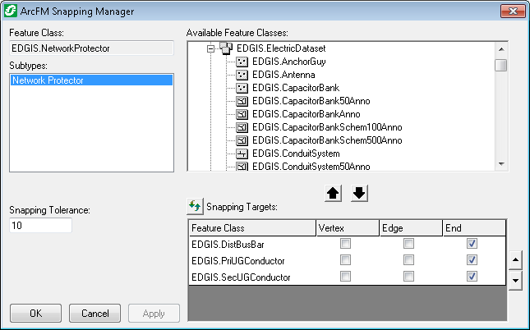

24810: Update to EDER Field Properties for Network Features

- Open ArcCatalog. Connect to database with EDGIS user.

- Navigate to EDGIS.TransformerDevice at the root level. Right click on it. Select "ArcFM Properties Manager".
- Select “Field Info” tab. Select SAPSORTFIELD. Set the field properties as below:

- Click Apply. Click OK.
- Navigate to ElectricDatasetEDGIS.NetworkProtector. Right click on it. Select "ArcFM Properties Manager".
- Select “Field Info” tab. Select LINKLOCATION. Set the field properties as below:

- Repeat step 6 for SUPERVISORYCONTROL and ENCLOSURETYPE field.
- Click Apply. Click OK.

- Navigate to ElectricDatasetEDGIS.OpenPoint. Right click on it. Select "ArcFM Properties Manager".
- Select “Field Info” tab. Select “Dead Break Elbow” subtype. Select SAPSORTFIELD. Set the field properties as below:

- Click Apply.

- Select INSULATINGFLUIDTYPE. Set the field properties as below:

- Click Apply. Click OK.

- Navigate to ElectricDatasetEDGIS.Switch. Right click on it. Select "ArcFM Properties Manager".
- Select “Field Info” tab. Select “Ground Switch” subtype. Select SAPSORTFIELD. Set the field properties as below:

- Click Apply.

- Select INSULATINGFLUIDTYPE. Set the field properties as below:

- Click Apply.

- Select SWITCHTYPE. Set the field properties as below:

- Click Apply. Click OK.

24890: Create FDI table and views

Data Model Configuration:

Create FDI Tables & Views
=========================

EDGIS Changes
-------------
1) In ArcCatalog, navigate to:
"\\sfetgis-nas01\sfgispoc_data\ApplicationDevelopment\IBM_Delivery\10.2.1\Releases\WEBR\EDVIEWER_v4.1.0\Data Model\webr410.gdb"
2) In ArcCatalog, copy the tables (PGE_FAULTDUTYIBAL, PGE_FDIDEVICESSUM, PGE_FDIDEVICESWIN) into the target EDER instance as edgis user
3) In ArcCatalog, add select/insert/update/delete permissions to the tables in step(2) by:
3a) Shift-click to select the tables
3b) Right-click Manage > Privileges
3c) User: GIS_I, View: Grant, Edit: Grant
3d) Repeat 3b/3c, although uncheck Edit (i.e. only Select), for User: SDE_VIEWER
3e) Repeat 3b/3c for User: SDE_EDITOR
3e) Repeat 3b/3c for User: MM_ADMIN
3f) Repeat 3b/3c for User: GISINTERFACE

4) Run the following SQL files as edgis on maintenance database:
- "\\sfetgis-nas01\sfgispoc_data\ApplicationDevelopment\IBM_Delivery\10.2.1\Releases\WEBR\EDVIEWER_v4.1.0\Data Model\1_create_fdi_view.sql"

Validation Steps
----------------
In ArcCatalog, connect to the target instance as a gis_i
Ensure that you can see the following tables in the root; EDGIS.ZPGEVW_FDIDEVICES, PGE_FAULTDUTYIBAL, PGE_FDIDEVICESSUM, PGE_FDIDEVICESWIN.

24864: Make MHCOVERSIZE field (Manhole Cover Size) of Subsurface Structure feature class visible

- Open ArcCatalog. Connect to database with EDGIS user.
- Navigate to ElectricDataset EDGIS.SubsurfaceStructure. Right click on it. Select "ArcFM Properties Manager".
- Select “Field Info” tab. Select MHCOVERSIZE. Set the “Visible” field properties as “Yes”:
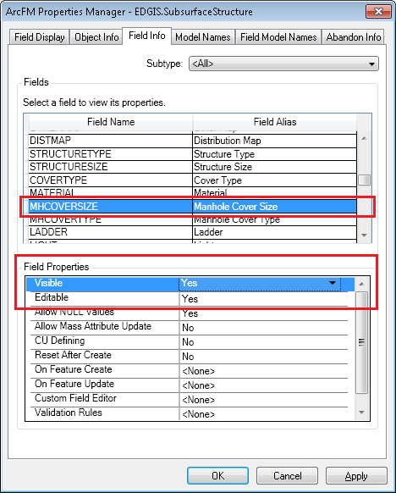

- Click Apply. Click OK.

25125: Resolve IVARA Device Manufacturer Domain and ED0006 domains.xml Defect
All changes below apply to the domain: Device Manufacturer
- Right Click on the Database connection root node. “Select Properties…”
- In Domains tab, navigate to Device Manufacturer domain.
- Change the description of code "CH" to "Cutler Hammer" (i.e. replace "-" with space)
- Change the description of code "FP" to "Federal Pacific"
- Change the description of code "WE" to "Westinghouse1"
- Change the description of code "W2" to "West"
- Add new member code "ET" description "ETI"
- Add new member code "NA" description "Not Available"
- Add new member code "WH" description "Westinghouse"

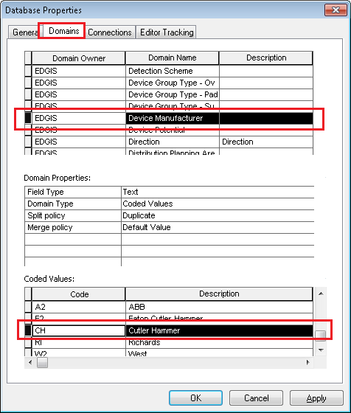
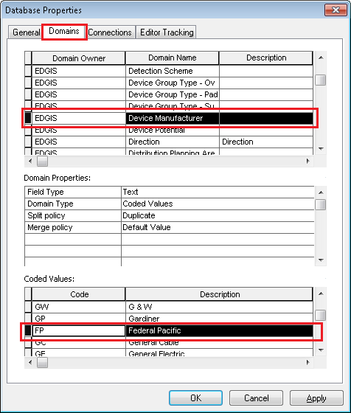

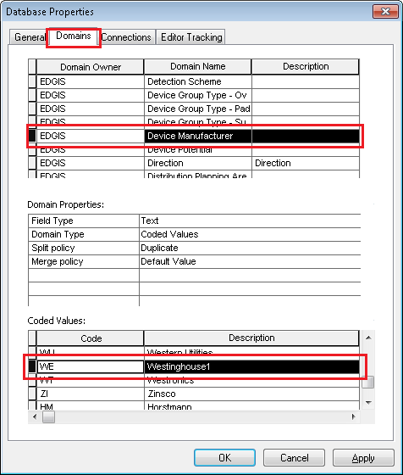

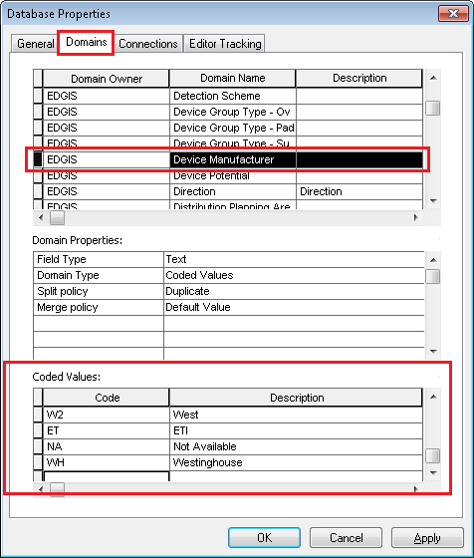
- Click Apply. Click OK.
- In ArcCatalog right click anywhere on the main toolbar and select Customize…
- Select the commands tab
- From the 'Developer Samples' commands category, add the 'Sort a domain' command to an existing toolbar or the context menu for a geodatabase.
- Note: If the category and/or Sort a domain command are not available, use ‘Add from File’ and load the DomainSort.dll from the shared path.
- Use ArcCatalog to browse to the EDER database to sort a domain from.
- Click on the command to bring up the dialog, and make choose below parameters for the sort.

- Available Domains: - Device Manufacturer
- Sort Type: - Ascending
- Sort Item:- Description
- Click on Ok.

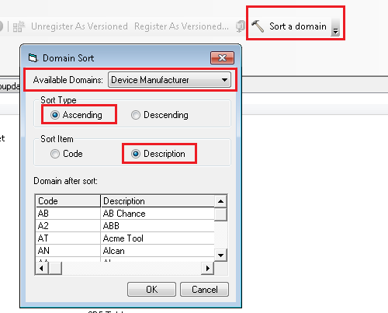

25185: Make SAPSORTFIELD field of Ground Switch visible
- Open ArcCatalog. Connect to database with EDGIS user.
- Navigate to ElectricDataset EDGIS.Switch. Right click on it. Select "ArcFM Properties Manager".
- Select “Field Info” tab. Select Ground Switch subtype. Select SAPSORTFIELD. Set the “Visible” field properties as “Yes”.

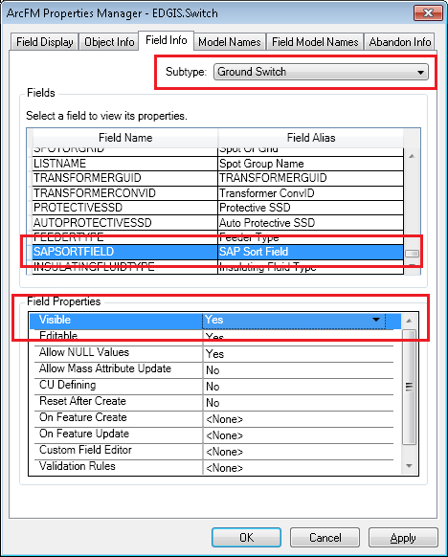
- Click Apply.

- Go to “Field Display” tab.
- Select SAPSORTFIELD. Place it below SAPEQUIPID using the arrow keys.

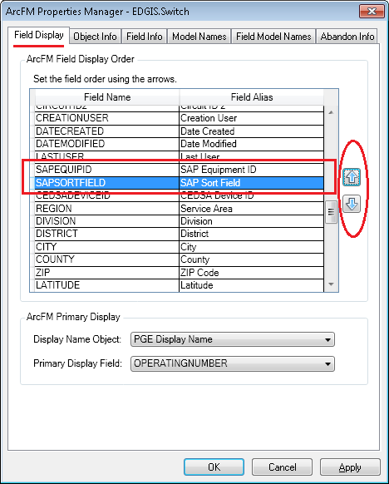

- Click Apply. Click OK.

25186: Make City and Zip fields of TransformerDevice (Primary Connection Chamber) visible
- Open ArcCatalog. Connect to database with EDGIS user.
- Navigate to EDGIS.TransformerDevice. Right click on it. Select "ArcFM Properties Manager".
- Select “Field Info” tab. Select City. Set the “Visible” and “Editable” field properties as “Yes”. Click Apply.
- Select Zip. Set the “Visible” and “Editable” field properties as “Yes”. Click Apply. Click OK.
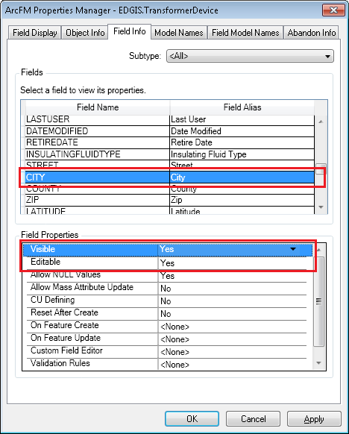

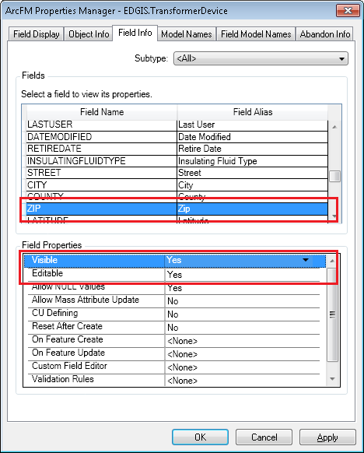

EDGIS 9.7.6B

25273: Remove "Validate Source Connectivity" QC rule from DC Features

- Right-click on DC Rectifier in the Electric Dataset and select ArcFM Properties Manager
- Select the Object Info tab
- Under Rules, find and unselect PGE Validate Source Connectivity

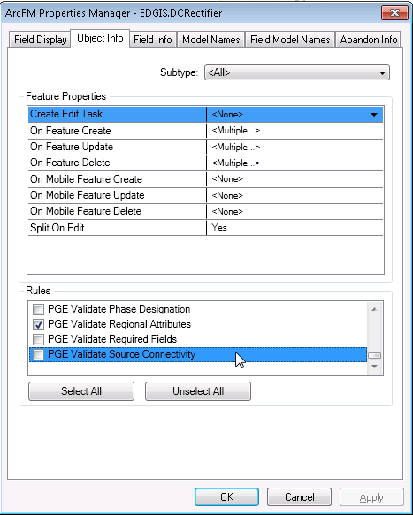

- Click on OK
- Repeat steps 1-4 for the DC Conductor feature class

25274: Prevent 50 scale linear features from resetting annotation when shape updated

- Right-click on PriUGConductor50Anno and select Properties
- Go to the Annotation tab
- Uncheck the checkbox for Update annotation when feature's shape is modified

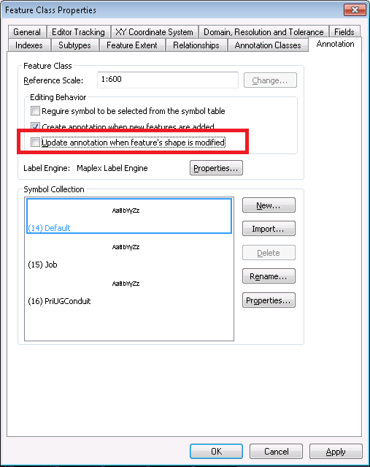

- Click on OK
- Repeat steps 1-4 for the following feature classes:

- PriOHConductor50Anno
- SecOHConductor50Anno
- SecUGConductor50Ano
- DCConductor50Anno

25413: Modify Transformer symbol number config

- Open ArcMap using EDGIS user.
- Open ED Mapping 1-50 stored display.
- Click on the “Symbol Number Config” command in the toolbar.
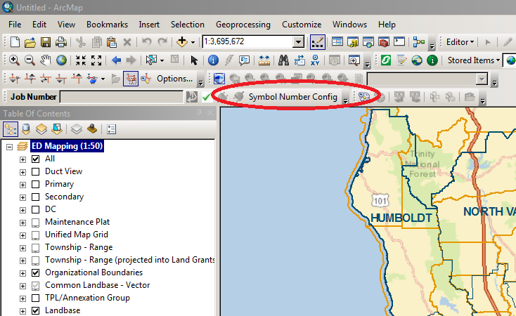

- If it is not available in the toolbar, double click on the empty place of the toolbar to open Customize window. Search for “Symbol Number Config” under “PGE Admin Tool”. Drag and drop it on the toolbar. Close Customize window. Click on the “Symbol Number Config” command in the toolbar.
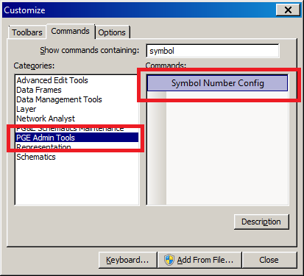
- Select EDGIS.ElectricDataset and EDGIS.Transformer feature class from the dropdown.
- Copy the whole content of Validation Rule Definition and paste it in a notepad. Save it as a backup.
- Delete the content from Validation Rule Definition text area. Make it blank.
- Open TransformerSymbolNumberXML.txt (available in the shared folder) and copy the content. Paste it into Validation Rule Definition.
- Click on Validate button. Click on Save button.
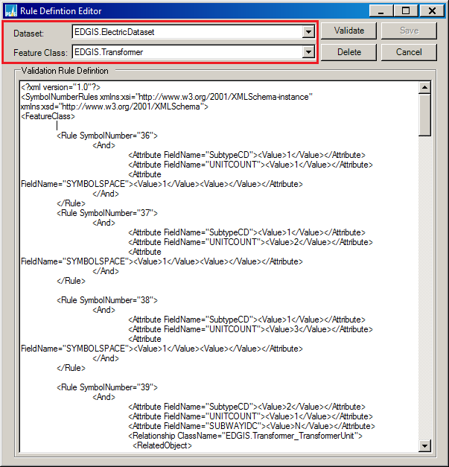

24170: PARS 114655 Missing code/value from "Trans Unit Type Sub Surface" domain

- In ArcCatalog right click anywhere on the main toolbar and select Customize…
- Select the commands tab
- From the 'Developer Samples' commands category, add the 'Sort a domain' command to an existing toolbar or the context menu for a geodatabase.
- Note: If the category and/or Sort a domain command are not available, use ‘Add from File’ and load the DomainSort.dll from the shared path.
- Use ArcCatalog to browse to the EDER database to sort a domain from.
- Click on the command to bring up the dialog, and make choose below parameters for the sort.
- Available Domains: - Trans Unit Type Sub Surface
- Sort Type: - Ascending
- Sort Item:- Description
- Click Ok.

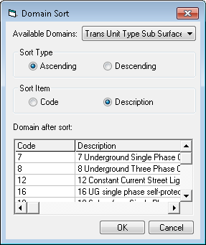

Update Data Model Version Table

Database Configuration:

- Open SQL Plus.
- Log in using the same server and user as was used in section 2.1.
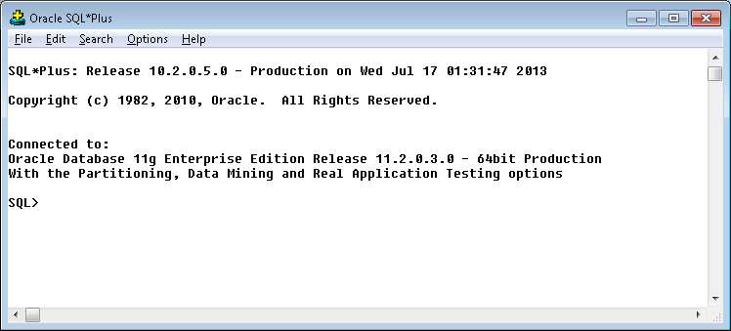
- Run the SQL below:

update pgedatamodelversion set currentidc='N' where currentidc='Y';

insert into pgedatamodelversion (OBJECTID, CURRENTIDC, DATEAPPLIED, APPLIEDBYPERSONNAME, MODELVERSION) values (SDE.VERSION_USER_DDL.NEXT_ROW_ID('EDGIS',(select registration_id from sde.table_registry where table_name='PGEDATAMODELVERSION')),'Y',sysdate,'<your_name>','9.7.6 GOLD');
commit;

Known Issues

<Please List any other issues encountered here while following the document>

